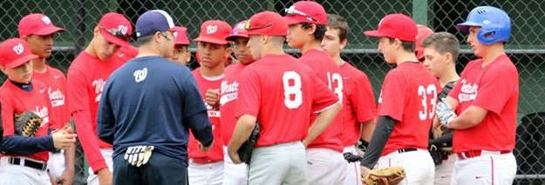
www.westchesteracademybaseball.com

WESTCHESTER ACADEMY BASEBALL
2017 SPRING BASEBALL TRY-OUTS

Tryout Dates (Select one): You only need to attend one of the two dates

Sunday, January 22nd
11U to 12U: 5:30PM – 7PM
13U to 15U: 6PM – 8PM
Location: SUNY Purchase College (Basketball Courts)
735 Anderson Hill Rd, Purchase, NY 10577

Sunday, January 29th
11U to 12U: 10:45 AM – 12PM
13U to 15U: 11:15AM – 1PM
Location: SUNY Purchase College (Basketball Courts)
735 Anderson Hill Rd, Purchase, NY 10577

***SUNY Purchase Tryout-When you enter the campus, park in Lots 6,7,8 and we are on the third floor in the basketball gymnasium.

Fee: The fee for the tryouts will be $20 per day

Spring Teams will be announced February 5th via email
11U/12U (46x60), 11U/12U (50x70), 13U, 14U & 14U/15U

To register please CLICK HERE to enter Westchester Academy Baseball website. Click on ONLINE REGISTRTION, fill out and then submit

Any Questions – Contact Edwin Diaz @ 917-679-3911 or Westchesteracademy@icloud.com

