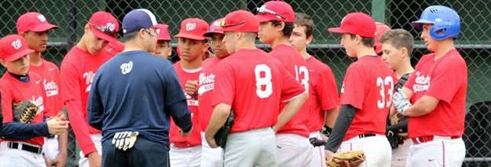
www.westchesteracademybaseball.com

WESTCHESTER ACADEMY BASEBALL
2018 SPRING & SUMMER BASEBALL TRY-OUTS

Tryout Dates (Select one): You only need to attend one of the two dates
***If you cannot attend one of the dates, contact me to set up a private evaluation***

Fee: The fee for the tryouts will be $20 per day

Saturday, January 20th, 2018
11U to 13U: 12:30PM – 2:30PM
14U to 16U: 1:30PM – 3:30PM
17U to 18U: 2:30PM – 4:00PM
Location: SUNY Purchase College (Basketball Courts)
735 Anderson Hill Rd, Purchase, NY 10577

Sunday, February 4th, 2018
11U to 14U: 11:00AM – 12:30PM
15U to 18U: 11:30AM – 1PM
Location: SUNY Purchase College (Basketball Courts)
735 Anderson Hill Rd, Purchase, NY 10577

Spring Teams will be announced February 10th via email
11U/12U (50x70), 11U/12U Cooperstown Team (50x70), 13U, 14U & 15U

Summer Teams will be announced March 3rd via email
11U/12U (50x70), 11U/12U Cooperstown Team (50x70), 13U, 14U, 15U, 16U & 18U

To register please copy the URL below and fill out the ONLINE REGISTRTION
https://www.leaguelineup.com/formpreview.asp?url=westchesteracademybaseball&formID=124663

Any Questions – Contact Edwin Diaz @ 917-679-3911 or Westchesteracademy@icloud.com

